  - Calculated Column
Added as per instructions. Set to date format to order as a date instead of alphabetically.
Names of months appear in English even though its all set to English in settings.
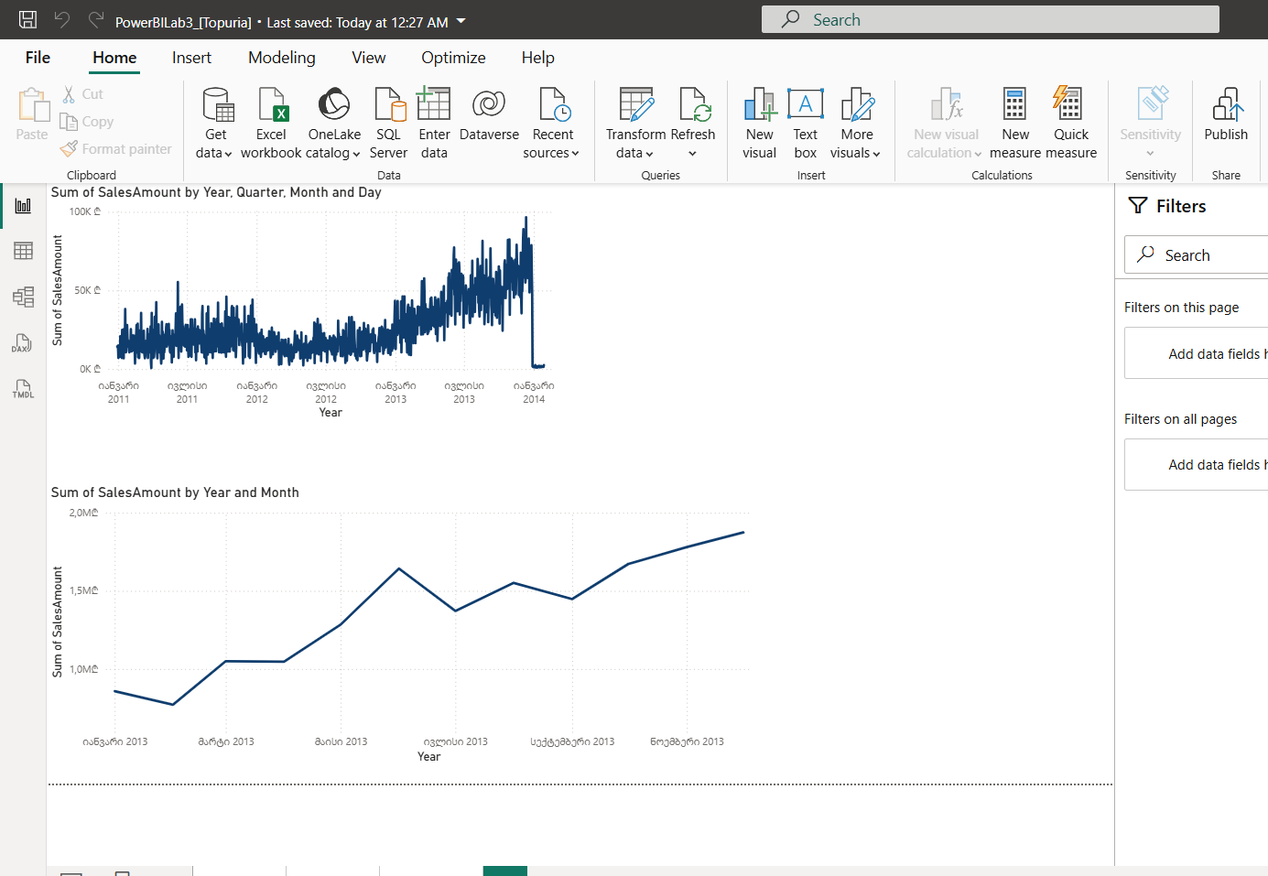
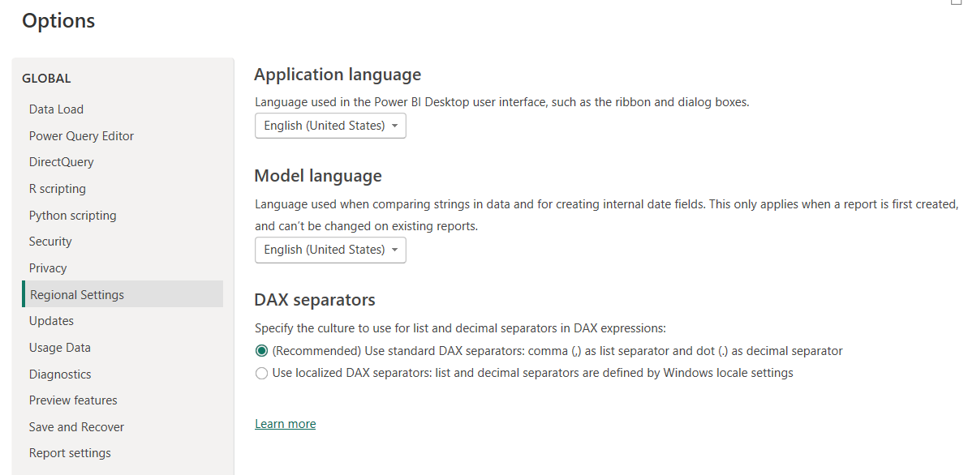

2
5)Latest day sales
Sales Amount Latest =
CALCULATE(
[Sales Amount],
FILTER(
ALL(FactInternetSales),
FactInternetSales[OrderDate] =
MAXX(ALL(FactInternetSales), FactInternetSales[OrderDate])
)
)
This measure finds the most recent order date and shows sales for that day. It updates automatically, so no manual changes are needed.

6)Top Country
Top Country =
CALCULATE(
SELECTEDVALUE(DimSalesTerritory[SalesTerritoryCountry]),
TOPN(
1,
ALL(DimSalesTerritory[SalesTerritoryCountry]),
[Sales Amount],
DESC
)
)
This measure finds the country with the highest total sales. It compares all countries and returns the one with the largest value.
7)Category ranking
Category Rank =
RANKX(
ALL(DimProductCategory),
[Sales Amount],
,
DESC
)
This measure ranks product categories based on sales amount. It orders them from highest to lowest, making it easy to identify the top-performing categories. RankX is a suitable for the task.

